# Interview Questions – Software Developer

14th July 2021

**Practical**

**Overview**

CIDRZ runs a state-of-the-art medical and research diagnostic laboratory in the Kalingalinga area of Lusaka. The laboratory supports commercial, research, and service projects by performing a range of assays of the following disciplines:

1. Haematology
2. Chemistry
3. Microbiology, including tuberculosis
4. HIV viral load monitoring
5. Immunochemistry
6. Serology
7. Molecular biology diagnostics

**Question 1.**

CIDRZ Lab runs a commercial Laboratory Information System (LIS). The LIS uses Microsoft SQL Server 2016 as the database engine. The database has the following schema:

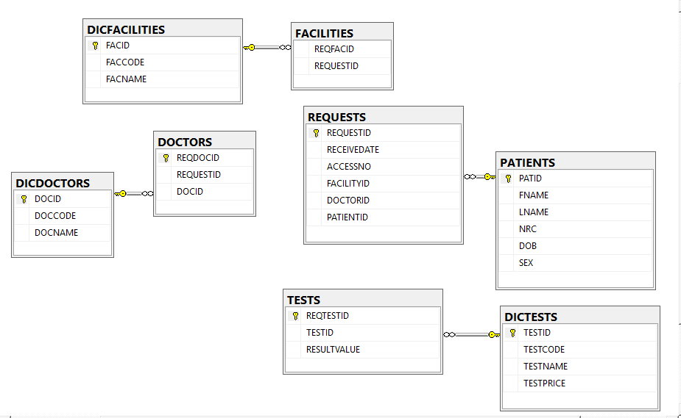

Figure 1: CIDRZ LIS Schema

**DICDOCTORS**

This table contains a list of doctors who refer patients to the lab. Example data is shown below.

|  |  |  |
| --- | --- | --- |
| DOCID | DOCCODE | DOCNAME |
| 1 | ARV | Antiretroviral |
| 2 | EMRG | EMRG Study |

**DICFACILITIES**

This table contains a list of facilities which submit samples to lab. Example data is shown below.

|  |  |  |
| --- | --- | --- |
| FACID | FACCODE | FACNAME |
| 1 | CHAI | Chaisa |
| 2 | TBCJ | TB - Chilenje |

**DICTESTS**

This table contains a list of laboratory tests performed by the lab. Example data is shown below.

|  |  |  |  |
| --- | --- | --- | --- |
| TESTID | TESTCODE | TESTNAME | TESTPRICE |
| 1 | ALP | Alkaline phosphatase | 20 |
| 2 | TRIC | Trichomonas | 30 |
| 3 | HIVAS | HIV Aliqote | 15 |
| 4 | HIVRE | HIV Resistance | 80 |
| 5 | POLY | Polychromasia | 25 |

**DOCTORS**

This table links a request to a doctor. Every request has a doctor who referred the patient to the lab. Example data is shown below.

|  |  |  |
| --- | --- | --- |
| REQDOCID | REQUESTID | DOCID |
| 1 | 1 | 2 |
| 2 | 2 | 1 |

**FACILITIES**

This table links facilities to requests. Every request has a request where facility were the patient and sample came from. Example data is shown below.

**PATIENTS**

Every request has a single patient assigned to it. Example data is shown below.

|  |  |  |  |  |  |
| --- | --- | --- | --- | --- | --- |
| PATID | FNAME | LNAME | NRC | DOB | SEX |
| 1 | Kelvin | Malama | 1111/11/1 | 23/11/1978 | 1 |
| 2 | Charity | Banda | 01/11/2222 | 01/02/1996 | 2 |

**REQUESTS**

A request links tests, patients, facilities and doctors. A request must have at least one test. Example data is shown below.

|  |  |  |  |
| --- | --- | --- | --- |
| REQUESTID | RECEIVEDATE | ACCESSNO | PATIENTID |
| 1 | 06/01/2019 | 901067234 | 1 |
| 2 | 16/01/2019 | 901167456 | 2 |

**TESTS**

This table holds tests for requests. Example data is shown below.

|  |  |  |  |
| --- | --- | --- | --- |
| REQTESTID | REQUESTID | TESTID | RESULTVALUE |
| 1 | 1 | 1 | 34 |
| 2 | 1 | 3 | 23 |
| 3 | 1 | 5 | 140 |
| 4 | 2 | 3 | 58 |
| 5 | 2 | 2 | 45 |
| 6 | 2 | 5 | 22 |
| 7 | 2 | 4 | 5 |

**Question 1A**

Write a query which displays all tests done at the lab in the year 2018. You should show the test name, result value, receive date, access no, facility name, doctor name, patient name, patient age and sex of the patient (1=Male, 2=Female)

**Question 2A**

Write a query which displays the total amount of money made by the lab per test. **Note that the lab has a promotion on the test ‘TRIC’ (50% off). You should also note that the lab bills all patients from the facility ‘CHA’ at 50% but only if they are female and below 18 (If they do not meet the condition, they pay the full amount).**

**Question 3A**

Write a query which displays the **3rd** most popular test at the lab.

**Question 4A**

Write a query which displays all lab requests. You should include the number of tests in that request and the test which had the highest result. For example

|  |  |  |  |  |  |
| --- | --- | --- | --- | --- | --- |
| REQUESTID | RECEIVEDATE | ACCESSNO | PATIENTID | TESTS | HIGHTEST |
| 1 | 06/01/2019 | 901067234 | 1 | 3 | Polychromasia |
| 2 | 16/01/2019 | 901167456 | 2 | 4 | HIV Aliqote |

**Question 2**

Ministry of health wants to access the tests performed by CIDRZ Laboratory remotely**.** Using the information in Question 1. Write a **Web Service** using a programming language of your choice which will receive a request ID and output the tests performed. You should include patient name, test name, result value, facility name, and doctor name. The output should be in XML format and must be a valid XML document.

**Question 3**

CIDRZ intends to collect information about facilities from remote areas and has purchased android devices to help in the exercise.

Write a native Android Mobile app or a web app. The app should collect the **facility code**, **facility name** and a **photo** of the facility. Users can either take a photo or select an existing one on the device. The app should allow users to add facilities even if they re offline and allow them to submit when they have an internet connection.

**You should extend the Web Service in Question 2 to allow it to interact with the Mobile App. You can use JSON for communicating with the app.**

**Question 4**

CIDRZ wants to display the tests it performs on a website and the cost of each test so that the general public can easily access the data. This website is a React web application.

Write a valid React app which will allow CIDRZ to achieve this.

**You should extend the Web Service in Question 2 to allow it to interact with the web app. You can use JSON for communicating with the website.**

**Question 5**

You have the following labels which are generated using ZPL programming language. Write **ZPL programming code** to produce each one of them. Refer to the Programming Guide sent to you via email.



